Name: _____________________________________ Phone: _____________________ email:______________________________________ Pickup or Ship: _________________________

|  |  |  |  |  |  |  |  |  |  |  |  |  |  |
| --- | --- | --- | --- | --- | --- | --- | --- | --- | --- | --- | --- | --- | --- |
| **Item** | **Type** | **Logo** | **Color** | **Size** | **Qty Q1** | | **Color** | **Size** | **Qty Q2** | **Q1+Q2** | | **Price (ea)** | **Extd Price** |
| Fitted Hat | Base | NV | Navy |  |  | | Black |  |  |  | | $24.00 |  |
|  | Plate | NV | Navy |  |  | | Black |  |  |  | | $24.00 |  |
|  | Combo | NV | Navy |  |  | | Black |  |  |  | | $24.00 |  |
| Fitted Hat | Base | MAC | Navy |  |  | | Black |  |  |  | | $24.00 |  |
|  | Plate | MAC | Navy |  |  | | Black |  |  |  | | $24.00 |  |
|  | Combo | MAC | Navy |  |  | | Black |  |  |  | | $24.00 |  |
| FlexFit Hat | Base | NV | Navy |  |  | | Black |  |  |  | | $24.00 |  |
|  | Plate | NV | Navy |  |  | | Black |  |  |  | | $24.00 |  |
|  | Combo | NV | Navy |  |  | | Black |  |  |  | | $24.00 |  |
| FlexFit Hat | Base | MAC | Navy |  |  | | Black |  |  |  | | $24.00 |  |
|  | Plate | MAC | Navy |  |  | | Black |  |  |  | | $24.00 |  |
|  | Combo | MAC | Navy |  |  | | Black |  |  |  | | $24.00 |  |
| VHSL Shirt S/S |  | VHSL |  |  |  | | Navy w/ R/W/N |  |  |  | | 35.00 |  |
|  |  | VHSL |  |  |  | | Black w/W |  |  |  | | 35.00 |  |
|  |  | VHSL |  |  |  | | Lt Blue w/B/W |  |  |  | | 35.00 |  |
| VHLS Shirt L/S |  | VHSL |  |  |  | | Navy w/ R/W/N |  |  |  | | 40.00 |  |
|  |  | VHSL |  |  |  | | Black w/W |  |  |  | | 40.00 |  |
| MLS Shirt S/S | w/stripes | Plain |  |  |  | |  |  |  |  | | $30.00 |  |
| **Colors:** | Navy w/ R/W/N | Lt Blue w/N/W | | Black w/W | | | Col blue w/B/W | Cream w/B | |  | | |  |
|  | Lt Blue w/B/W | White w/N/R/W | | Red w/N/W | | |  |  | |  | | |  |
| MLS Shirt L/S | w/stripes | Plain |  |  |  | |  |  |  |  | | $38.00 |  |
| **Colors:** | Navy w/ R/W/N | Lt Blue w/N/W | | | | | Black w/W |  | |  | | |  |
| MLS Shirt S/S | Side Panel | Plain |  |  |  | | Black w/Gray |  |  |  | | $35.00 |  |
|  |  | Plain |  |  |  | | Gray w/Black |  |  |  | | $35.00 |  |
|  |  | Plain |  |  |  | | Sky blue w/B |  |  |  | | $35.00 |  |
| MLS Shirt L/S | Side Panel | Plain |  |  |  | | Black w/G |  |  |  | | $42.00 |  |
|  |  | Plain |  |  |  | | Sky blue w/B |  |  |  | | $42.00 |  |
| Pants: 100% Poly | Base | Plain | Heather |  |  | | Charcoal Gray |  |  |  | | $48.00 |  |
|  | Plate | Plain | Heather |  |  | | Charcoal Gray |  |  |  | | $48.00 |  |
|  | Combo | Plain | Heather |  |  | | Charcoal Gray |  |  |  | | $48.00 |  |
| Pants: 4-way stretch | Base | Plain | Heather |  |  | | Charcoal Gray |  |  |  | | $60.00 |  |
|  | Plate | Plain | Heather |  |  | | Charcoal Gray |  |  |  | | $60.00 |  |
|  | Combo | Plain | Heather |  |  | | Charcoal Gray |  |  |  | | $60.00 |  |
| Leather Belt |  |  |  |  |  | | Black |  |  |  | | $20.00 |  |
| Patent Belt |  |  |  |  |  | | Black |  |  |  | | $30.00 |  |
| Ball Bag |  | Navy |  |  |  | | Black |  |  |  | | $10.00 |  |
| Brush |  | Plastic |  |  |  | | Wood |  |  |  | | $5.00 |  |
| Indicator | 3-2-2 - plastic |  |  |  |  | |  |  |  |  | | $6.00 |  |
| Indicator | 4-way plastic |  |  |  |  | |  |  |  |  | | $18.00 |  |
| Indicator | 4-way metal |  |  |  |  | |  |  |  |  | | $18.00 |  |
| Mask | Diamond IX3 |  |  |  |  | | Black |  |  |  | | $110.00 |  |
| Mask | Markwort |  |  |  |  | | Black |  |  |  | | $60.00 |  |
| Mask | Pro Nine |  |  |  |  | | Black |  |  |  | | $75.00 |  |
| Throat Guard | Large |  |  |  |  | | Black |  |  |  | | $9.00 |  |
| Throat Guard | Small |  |  |  |  | | Black |  |  |  | | $8.00 |  |
| Shin Guards | Markwort |  |  |  |  | | Black |  |  |  | | $45.00 |  |
| Shin Guards | Champro |  |  |  |  | | Black |  |  |  | | $89.00 |  |
| Shin Guards | Diamond IX3 |  |  |  |  | | Black |  |  |  | | $105.00 |  |
| Shin Guards | Diamond DLG-UXS |  |  |  |  | | Black |  |  |  | | $75.00 |  |
| Chest Protector | Diamond IX3 |  |  |  |  | | Black |  |  |  | | $125.00 |  |
| Chest Protector | Pro Nine |  |  |  |  | | Black |  |  |  | | $125.00 |  |
| Chest Protector | Wilson - platinum |  |  |  |  | | Silver |  |  |  | | $199.00 |  |
| Jacket | Lt Weight, Pullover |  |  |  |  | | Black w/W |  |  |  | | $49.00 |  |
| Jacket | Thermal, Zip |  |  |  |  | | Black w/W |  |  |  | | $72.00 |  |
| Base Shoes | 3N2 |  |  |  |  | | Black |  |  |  | | $75.00 |  |
| Base Shoes | New Balance, Smitty |  |  |  |  | | Black |  |  |  | | $90.00 |  |
| Plate Shoes | 3N2 |  |  |  |  | | Black |  |  |  | | $110.00 |  |
| Plate Shoes | New Balance, Smitty |  |  |  |  | | Black |  |  |  | | $160.00 |  |
| Cup Kit (w/supporter) |  |  |  |  |  | | M, L, XL |  |  |  | | $15.00 |  |
| Cup |  |  |  |  |  | | One size |  |  |  | | $10.00 |  |
|  | | | | | | **TOTAL (before tax / shipping** | | | | |  | | |

**Note – Prices are subject to change without notification.**

**To Ship – please indicate full address and credit card info**

|  |  |
| --- | --- |
| Name and Shipping Address: | Credit Card Billing Address (if different from ship address): |

|  |
| --- |
| Credit Card Info:  Name:  Number:  Exp Date:  Security Code: |

Sizing info:

Fitted Hat sizes: 6 3/4, 6 7/8, 7, 7 1/8, 7 1/4, 7 3/8, 7 1/2, 7 5/8, 7 3/4, 7 7/8, 8

Flex Fit Hat sizes: S/M, L/XL

Shirt /Jacket sizes: S, M, L, XL, 2XL, 3XL, 4XL

Pants sizes: 28, 30, 32, 34, 36, 38, 40, 42, 44, 46, 48 50

Belt sizes: 30, 32, 34, 36, 38, 40, 42, 44, 46, 48 50, 52

Shoes sizes – 7, 7.5, 8, 8.5, 9, 9.5, 10, 10.5, 11, 11.5, 12, 13, 14 (3N2 also comes in Wides – indicate with a W)

Color Codes: B = Black, N = Navy, W = White, G = Gray, R = Red

Shirts:

[[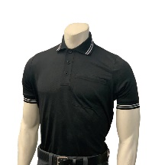](https://smittyapparel.com/cdn/shop/products/BBS307_BLACK_Pic_002_1800x1800.jpg?v=1581105320)](https://smittyapparel.com/cdn/shop/products/BBS307_BLACK_Pic_002_1800x1800.jpg?v=1581105320)[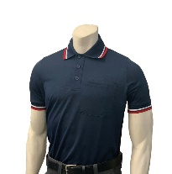](https://smittyapparel.com/cdn/shop/products/BBS307_NAVY_Pic_002_1800x1800.jpg?v=1581105320) [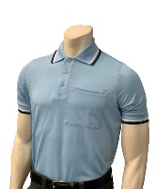](https://smittyapparel.com/cdn/shop/products/BBS307_PB_Pic_002_1800x1800.jpg?v=1581105320) [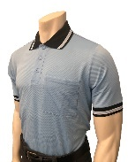](https://smittyapparel.com/cdn/shop/products/BBS307PBwithBlackPicture_002_1800x1800.jpg?v=1585076665) [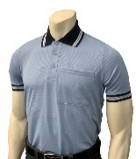](https://smittyapparel.com/cdn/shop/products/BBS307_CAROLINA_BLUE_Pic_002_1800x1800.jpg?v=1581105320) [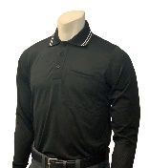](https://smittyapparel.com/cdn/shop/products/BBS308_BLACK_Pic_003_4f8bc6cd-5278-4cab-b953-27e38441f301_1800x1800.jpg?v=1581103882) [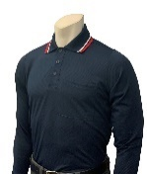](https://smittyapparel.com/cdn/shop/products/BBS308_NAVY_Pic_003_1800x1800.jpg?v=1581103789) [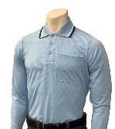](https://smittyapparel.com/cdn/shop/products/BBS308_POWDER_BLUE_Pic_003_1800x1800.jpg?v=1581103789)

[[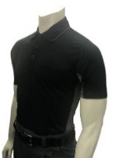](https://smittyapparel.com/cdn/shop/products/BBS314_BK_CG_1800x1800.jpg?v=1553709713) [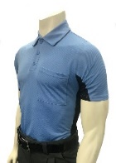](https://smittyapparel.com/cdn/shop/products/BBS314_SB_BK_1800x1800.jpg?v=1553709713) [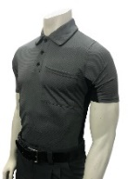](https://smittyapparel.com/cdn/shop/products/BBS314_CG_BK_ed96fc60-1d9c-488f-873c-d8647eb1064e_1800x1800.jpg?v=1553709713) [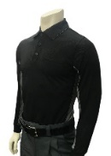](https://smittyapparel.com/cdn/shop/products/BBS315_BK_CG_1800x1800.jpg?v=1551472157) [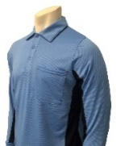](https://smittyapparel.com/cdn/shop/products/BBS315pic_003_1800x1800.jpg?v=1600804640)](https://smittyapparel.com/cdn/shop/products/BBS314_SB_BK_1800x1800.jpg?v=1553709713)

[Jackets:](https://smittyapparel.com/cdn/shop/products/BBS314_BK_CG_1800x1800.jpg?v=1553709713)

[[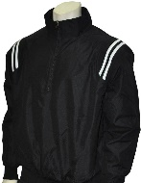](https://smittyapparel.com/cdn/shop/products/BBS320-BLK_WH_TRIM_1800x1800.jpg?v=1550023172) [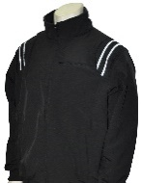](https://smittyapparel.com/cdn/shop/products/BBS330-BLK_W_1800x1800.jpg?v=1550023149)](https://smittyapparel.com/cdn/shop/products/BBS320_1800x1800.jpg?v=1550023172)