**Proposed Amendments to Uniform Policy**

Any changes made to the uniform policy will include a two-year integration period. This means that items added to the policy (such as skull caps or shorts) are authorized immediately. However, changes (such as from navy blue to black) can take place gradually, to allow officials time to acquire the appropriate attire. Most scholastic umpires should have multiple uniform color combinations; therefore, this change should not impact umpires to any significant degree.

Amendment #1 – Change in Default Uniform Color

The proposed amendment would eliminate ***all of Part Two*** and replace it with the following language.

**PART TWO –** Uniform Colors and Styles

1. The primary shirt color is black with white trim. Alternate uniform color combinations (such as light blue with black trim or black piping, navy blue with red and white trim, or black with grey piping) are also authorized.
2. The primary color for the uniform pants is charcoal grey. Heather grey is an acceptable, but not preferred option. To the extent possible, the color of the uniform pants should match.
3. The primary color for undershirts is black. No option is authorized for black shirts. See the uniform chart to determine which color combinations are authorized for other colors.

Amendment #2 – Cold Weather Adjustments

The proposed amendment would add Part 3 to the Uniform Policy

**PART** **THREE** – Special Circumstances

* 1. For travel baseball games (excluding tournaments or showcases) and other recreational baseball leagues (excluding tournaments or showcases) during periods of cold weather, umpires may choose to wear a knit wool cap/beanie. The primary/preferred color is black (navy is also acceptable). The standard requirements are no pom-pom style hats, no patterns, no stripes, no graphics, no non-Association-related logos, no elaborate weaves or textures. The letters **NV** or **MAC** in plain, block font oran **NVBUA** or **MAC** association patch are acceptable.

Amendment #3 – Hot Weather Adjustments

The proposed amendment would add Part 3 to the Uniform Policy

1. For travel baseball and other recreational baseball leagues (excluding tournaments or showcases) during periods of exceptionally hot weather, umpires may choose to wear shorts. The primary color is charcoal grey. This is an option for base umpires only. The plate umpire must wear the full-length pants as described above. Length of shorts should be tailored to either AT or ABOVE the knee, +/- 1-inch. In addition to the color and length standards the shorts should be plain in their appearance. Cutoffs, short-shorts, gym shorts, cargo shorts are prohibited. The shorts must have no prints, patterns, graphics and no large logos. Golf shorts or business-casual type shorts are acceptable. It is the responsibility of the umpire to maintain a professional appearance that is consistent with the high standards of NVBUA-MAC. Low-cut black preferred (Navy Blue is also acceptable) socks are to be worn with shorts, no knee-high length socks can be worn with shorts. Any questions about the application of these policies to a specific game an umpire is scheduled for should be directed to the MAC/NCBUA Commissioner’s Office.

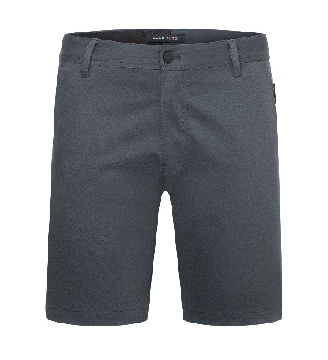

Amendment #4 – Hot Weather Adjustments

The proposed amendment would add Part 3 to the Uniform Policy

1. For travel baseball and other recreational baseball leagues (excluding tournaments or showcases) during periods of exceptionally hot weather, umpires may choose to wear a tee shirt. The authorized colors are either navy blue or black. This is an option for base umpires only. The tee shirt must contain an NVBUA-MAC logo. It is the responsibility of the umpire to maintain a professional appearance that is consistent with the high standards of NVBUA-MAC. Any questions about the application of these policies to a specific game an umpire is scheduled for should be directed to the MAC/NCBUA Commissioner’s Office.

