NVBUA MAC Uniform Policy

The following document represent the uniform policy of the Northern Virginia Umpire Association (NVBUA) Mid-Atlantic Collegiate (MAC) umpire association. This policy supersedes any previous association policy. Unless otherwise stated, this policy is in effect for scholastic (high school) and recreational (travel, recreational, tournament, and adult leagues) games only. This policy is not intended for collegiate games, either in-season or summer games. If any official is unsure whether or not a particular game is covered by this policy, he or she should contact the commissioner responsible for assigning that game.
This policy covers uniform caps, shirts, undershirts, pants, belts, shoes and socks. In cold weather, the policy covers jackets and any additional protective headwear. For plate umpires, the policy covers ball bags as well.
PART ONE – Uniform Policies
- Uniforms must be clean, pressed, and in good condition. Uniform caps must be free of visible dirt or sweat stains.
- Due to the size of the association, different caps are required for different regions.
  - The following policy relates to public and private high school leagues. In the Northern Virginia counties of Arlington, Fairfax, Loudoun, Prince William, Fauquier and the cities of Alexandria, Falls Church, Manassas Park, and Manassas umpires are expected to wear caps with the “NV” logo on them. In all other regions, umpires are expected to wear caps with the “MAC” logo on them.
  - For recreational baseball, umpires are expected to wear matching caps.
- Uniform colors and trim styles must match. Please refer to the charts below to verify which color combinations are authorized.
- Special color combinations, intended for special occasions (such as cancer awareness or holidays) are permitted.
- Uniform accessories, such as ball bags and caps should match the uniform shirt, according to the chart below.
- Uniform standards for undershirts only apply to field umpires and do not apply if the field umpire is wearing a jacket during a game.
- Umpires are expected to wear state patches at all public school varsity scholastic games. Patches are optional in Junior varsity games.
  - In Virginia, if a jacket is not worn, a Virginia High School League (VHSL) patch should be displayed on the front left breast of the uniform shirt.
  - In Maryland, if a jacket is not worn, a Maryland Public School Secondary Athletic Association (MPSSAA) patch should be displayed on the left sleeve of the umpire uniform.
  - Patches are not appropriate for private school games, unless that school belongs to a conference that includes public schools and those schools expect the umpires to wear a state patch.
- Black socks and a black belt are required.
- Plate shoes and umpire field shoes are required. Umpires who do not wear plate shoes risk injury. Violations should be reported in an umpire’s post-game evaluation.
- Minor uniform policy violations should be reported in an umpire’s post-game evaluation.
- Cold weather apparel such as gloves and protective headwear are authorized.

PART TWO – Uniform Colors and Styles
- The primary shirt color is navy blue with red trim. Alternate uniform color combinations (such as light blue with black trim/black piping, black with white trim/grey piping) are acceptable.
- The primary color for the uniform pants is charcoal grey. Heather grey is an acceptable, but not preferred option. To the extent possible, the color of the uniform pants should match.
- The primary color for undershirts is navy blue. See the uniform chart to determine which color combinations are authorized for other colors.

APPENDIX – Combinations and authorized colors - applies to long and short sleeve shirts
Shirt and Jacket Color and Trim | Undershirt | Hat and Ball Bags | Example
Black/White Trim | Black | Black | 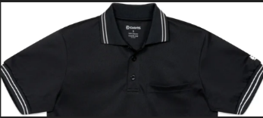
Black/Grey Piping | Black | Black | 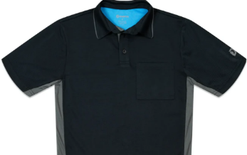
Light Blue/Black Trim | Black preferred – white/navy acceptable | Black preferred – navy acceptable | 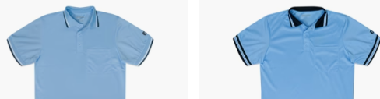
Light Blue/Black Piping | Black preferred – white/navy acceptable | Black preferred – navy acceptable | 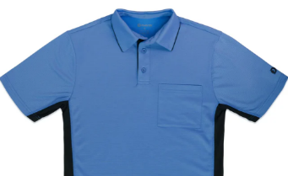
Navy w/ Red and White Trim | Navy preferred – red acceptable | Navy | 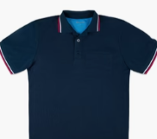
Blue Jacket- Thermal and Windbreaker; Red and White Trim | Does require an appropriate shirt underneath | Navy | 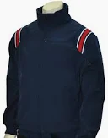
Black Jacket- Thermal and Windbreaker; Black and White Trim | Does require an appropriate shirt underneath | Black | 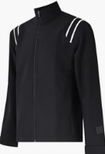
Black Jacket – Thermal and Windbreaker; Black and Grey Trim | Does require an appropriate shirt underneath | Black | 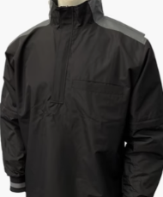
All Black Jacket –Windbreaker; No Trim “Trashbag” | Does require an appropriate shirt underneath | Black | 